Maalem bin idik

1. **Specifications**
   1. Context.
   2. Objectives.
   3. The Target.
   4. Description of the needs.

# UML & MERISE

* 1. Use case Diagram.
  2. Class Diagram.
  3. Conceptual data model.

1. **Screenshot of different pages**
2. **Security mesures taken into consideration**

1. **Specifications**

## Context.

Coronavirus has impacted economically and socially on the population, the latter has led to the loss of jobs and income, without knowing when they could be restored. Some sectors have suffered such as tourism and crafts etc. Maalam bin idik is a web application that comes as a solution to help craftsmen (plumber, electrician ...) to find a job that they have lost due to covid19, also making it easier for individuals to find competent craftsme . It offers a well-organized artisans presentation space (sorts, choice by city, etc.) to facilitate the choice for the user or the customer, as well as a simplified interface for the registration of artisans. Sometimes offers freebies for loyal customers.

## Objectives.

* Craftsmen can post their services.
* Users can see the services as well as order them.

## The Target.

* Main target: open to the public (over 20 years old).

## Description of the needs

|  |  |
| --- | --- |
| **Need** | **Description** |
| **Account management** | **Users / craftsmen can create their account and modify them at any time** |
| **Service area** | **Craftsmen can post their services and modify or delete them and users can see them ordering them, with a simple interface with the possibility of filtering by city / profession** |
| **Data Security** | **Fixed vulnerabilities (Cross-Site Request Forgery (CSRF) / Version Disclosure (ASP.NET MVC) / Sensitive Data Exposure) thus creating a maintenance plan and given security tips to users.** |
| **Compatibility** | **the application must be compatible with all devices (laptop / mobile / tablet)** |

1. **Specifications**
   1. **Use case Diagram.**

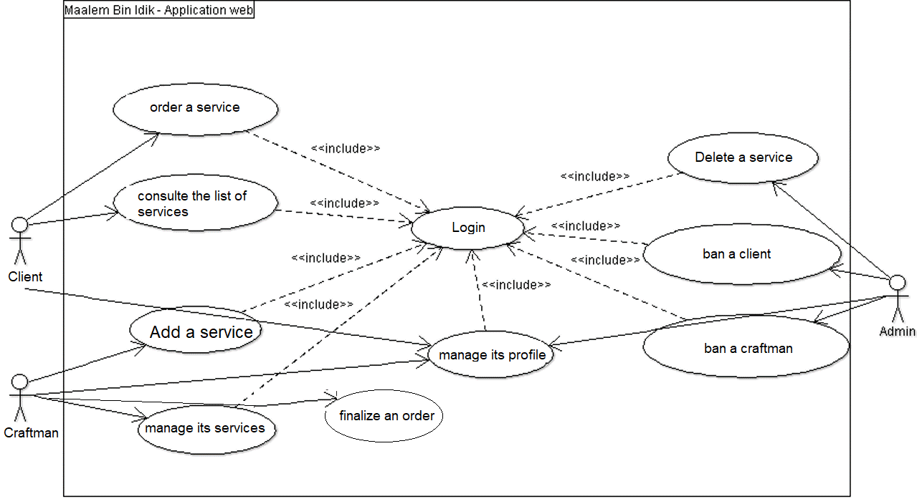

* 1. **Class Diagram.**

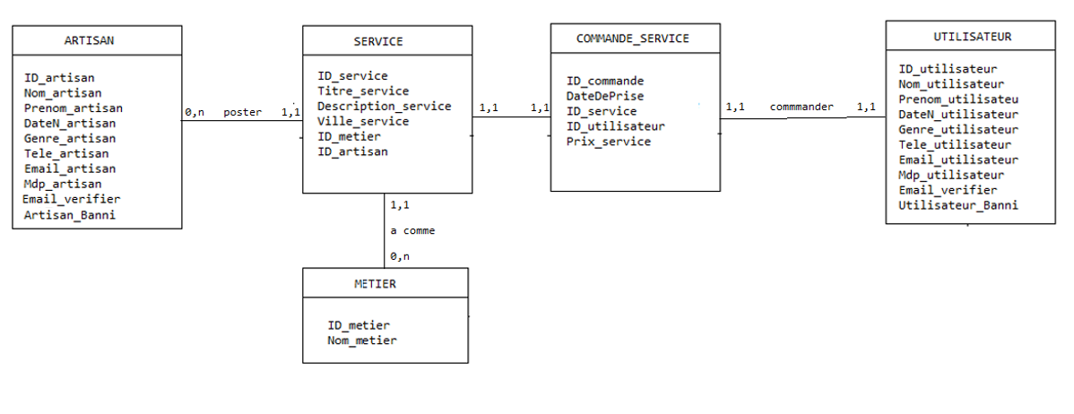

* 1. **Conceptual data model**

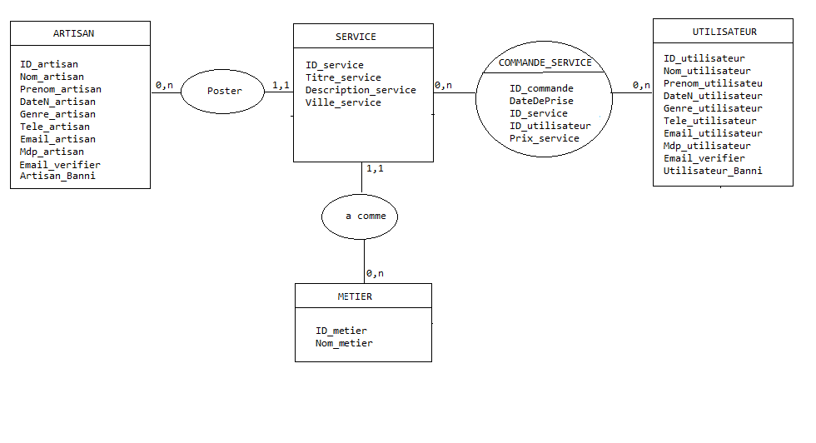

**Screenshot of different pages**

**Home pages Desktop & Mobile version :**

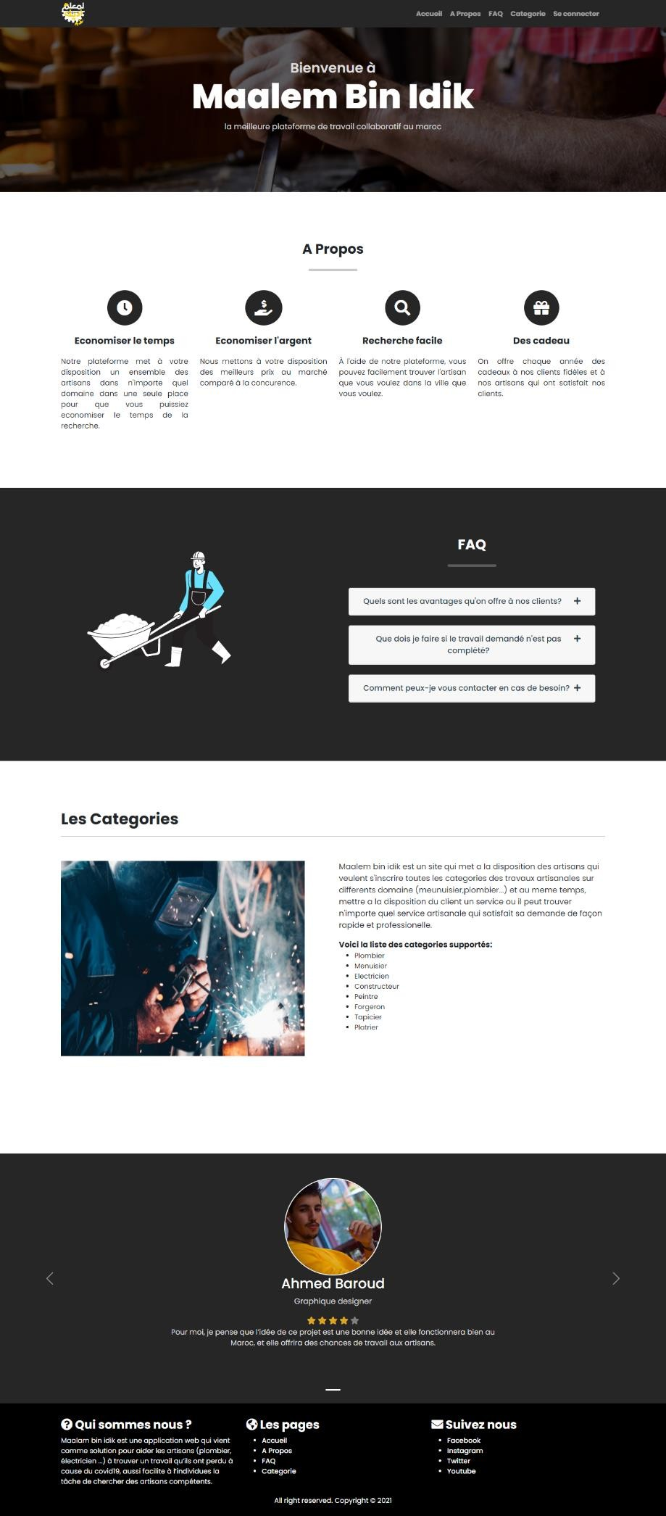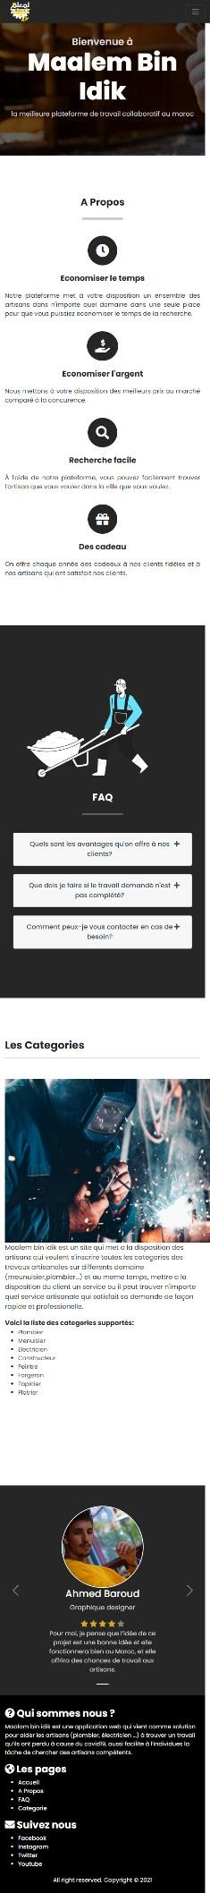

**Login et registration pages Desktop version :**

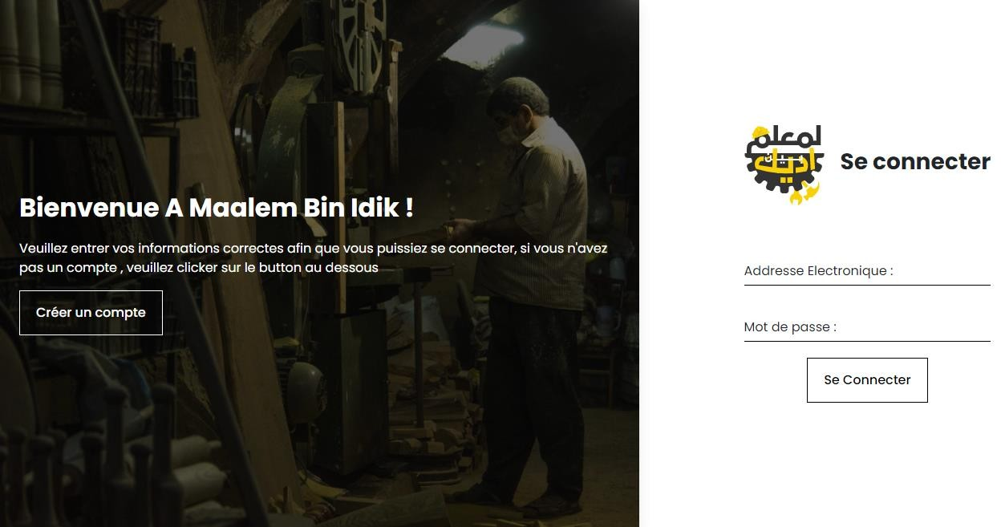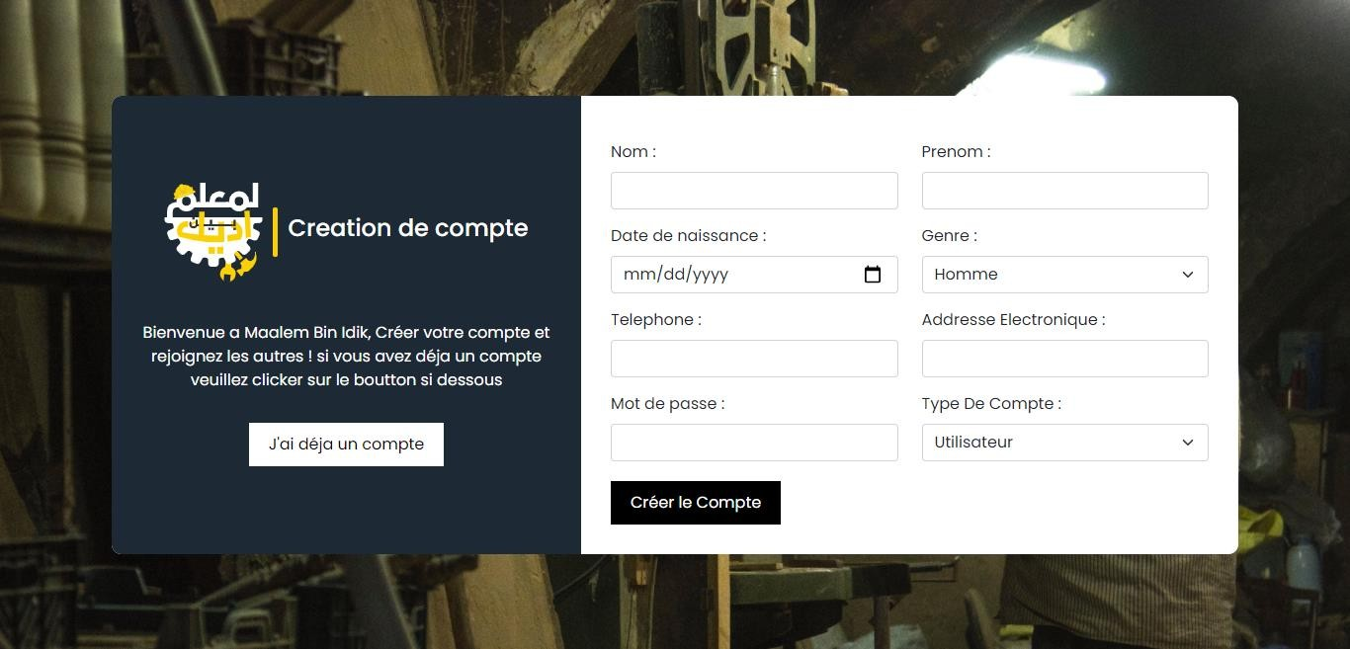

**Login et registration pages Mobile version :**

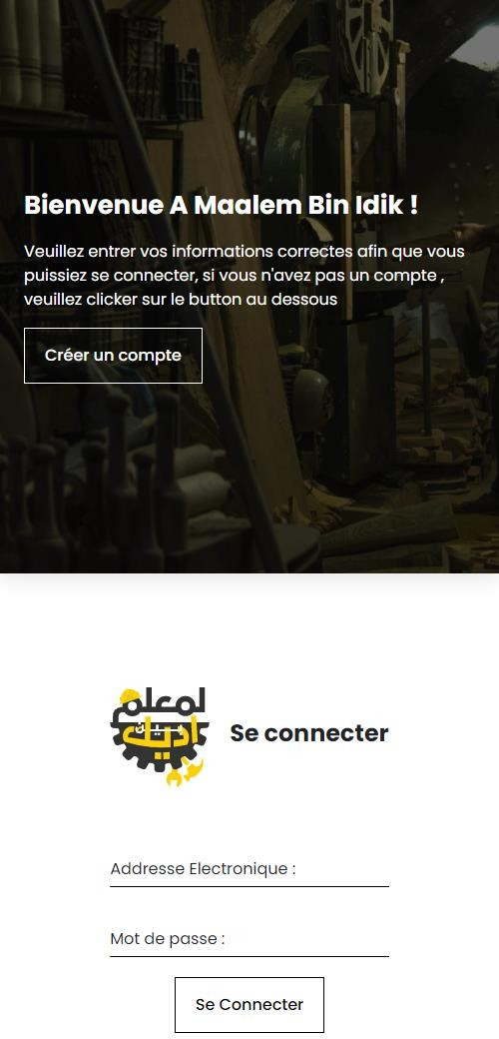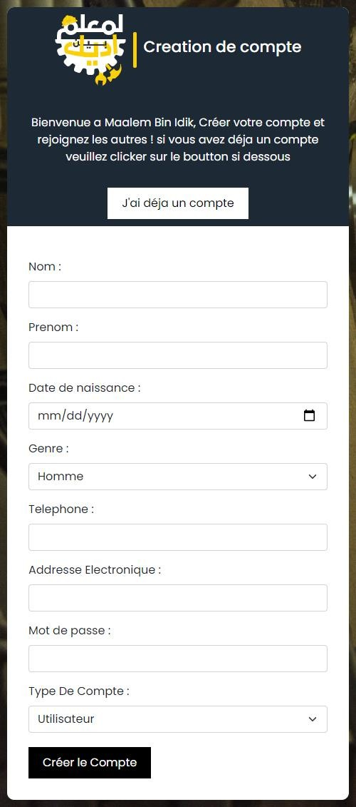

**User space mobile & desktop version**

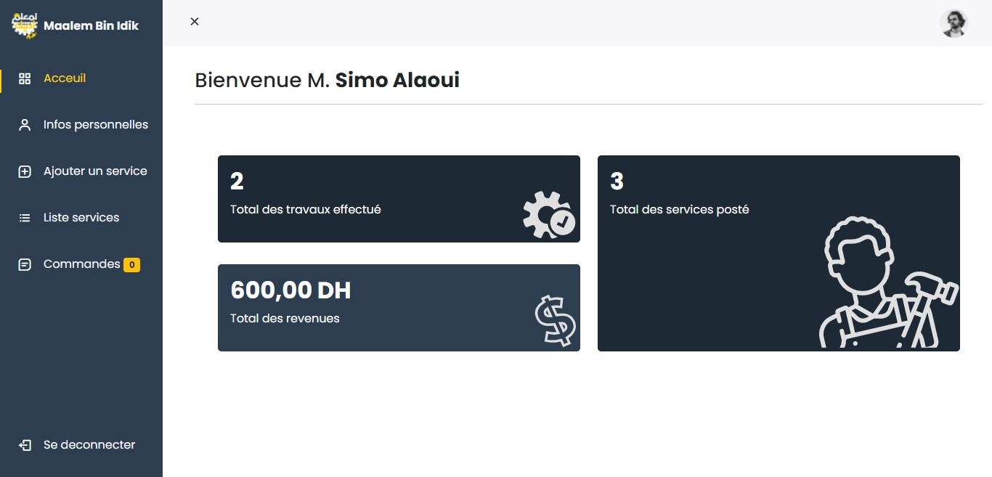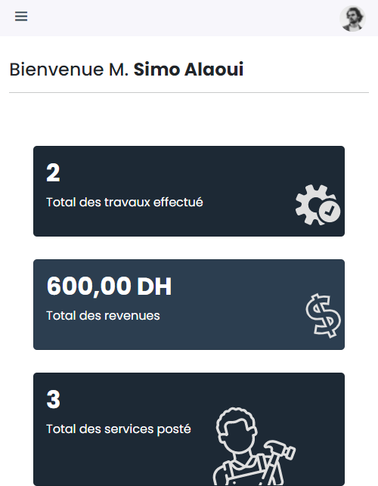

**Add a service page mobile & desktop version :**

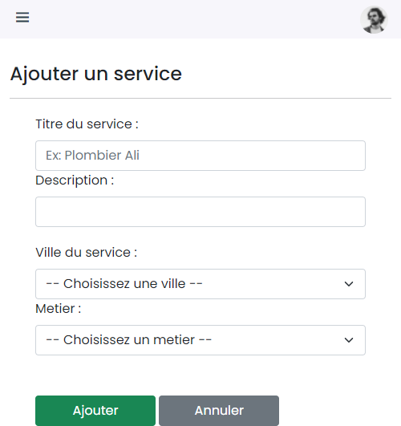

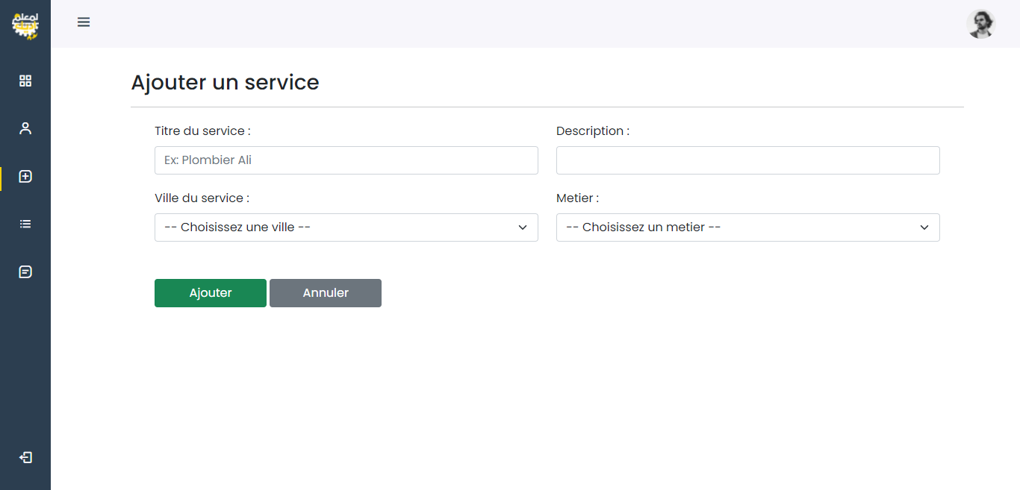

**NB : a confirmation message will be displayed if the service is added otherwise an error message.**

**Modification of personal information page mobile & desktop version :**

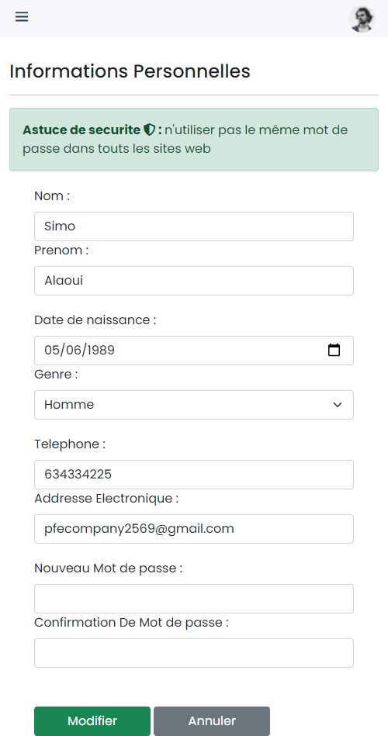

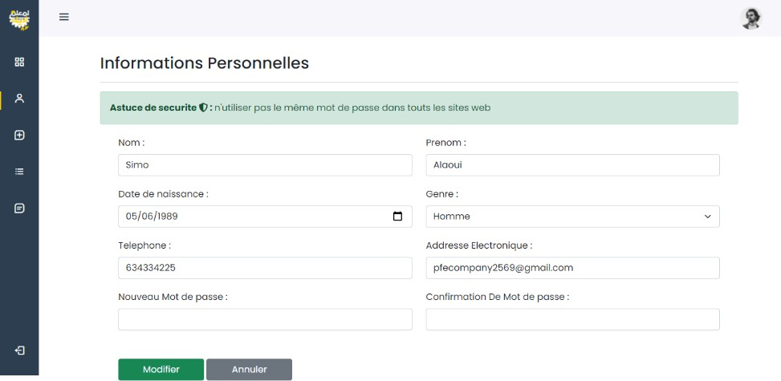

**List of services per craftman page mobile & desktop version :**

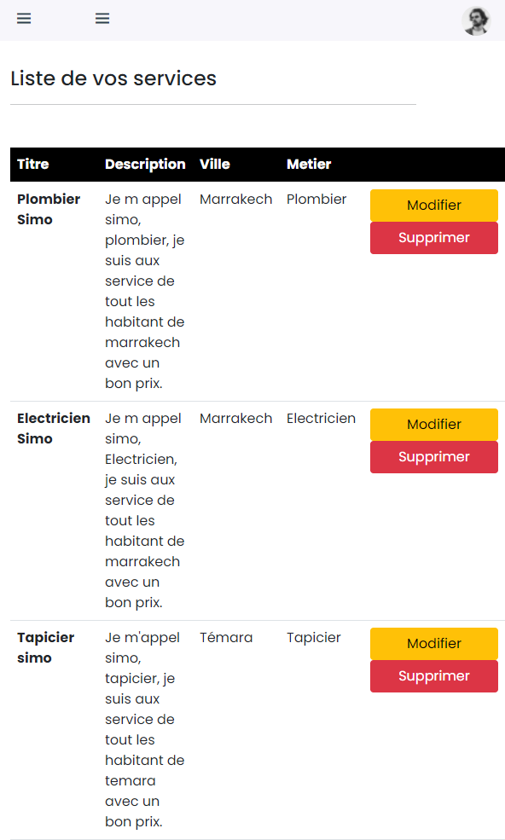

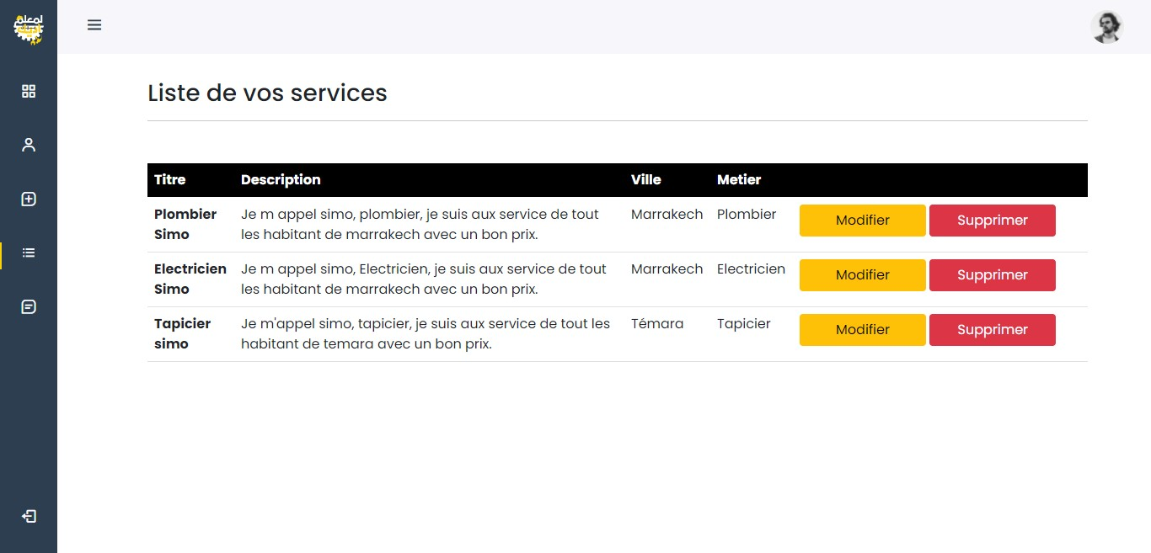

**Service modification page mobile & desktop version :**

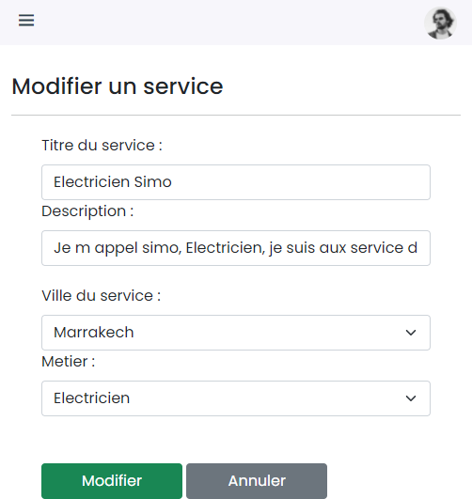

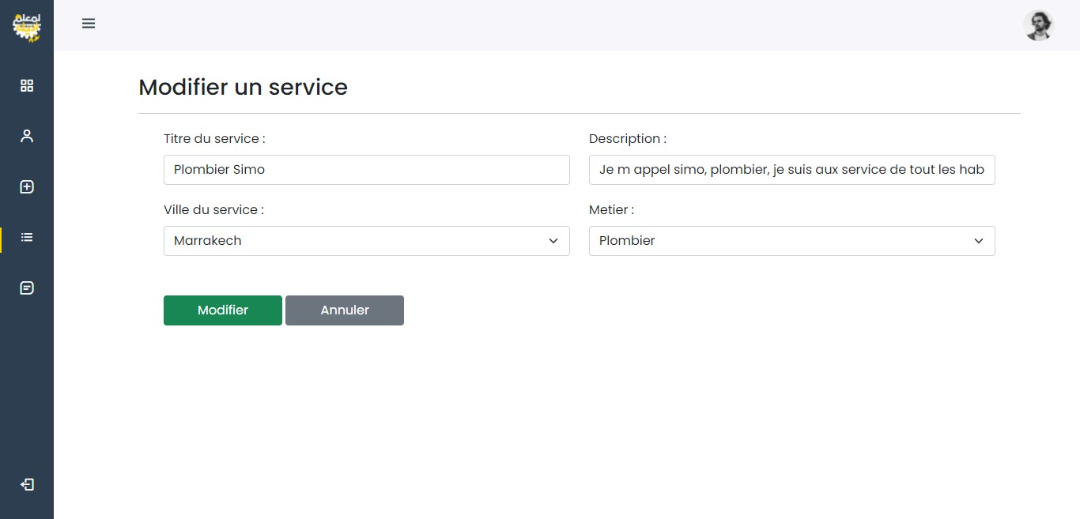

**Service deletion page mobile & desktop version :**

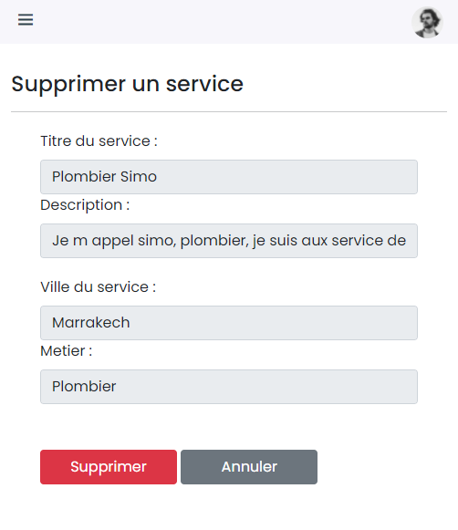

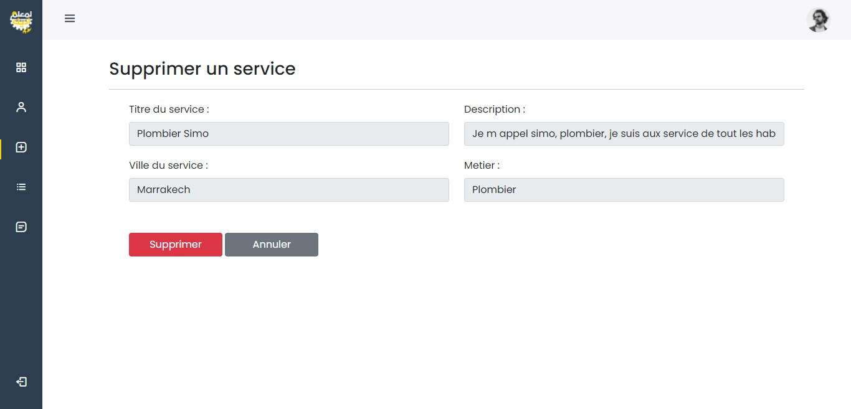

**List of orders to be finalized page mobile & desktop version :**

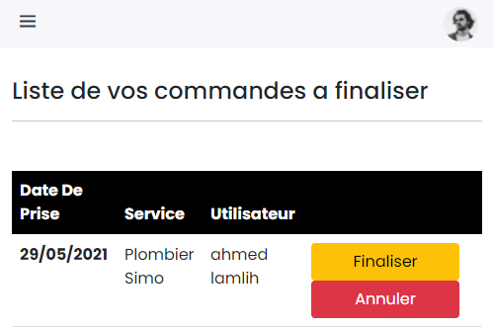

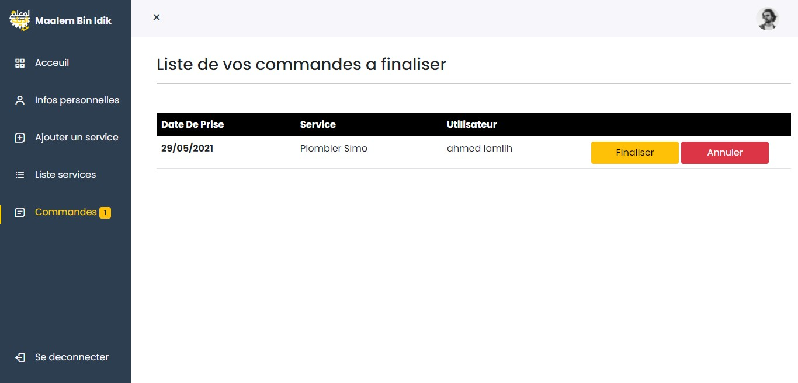

**Order finalization page desktop & mobile version :**

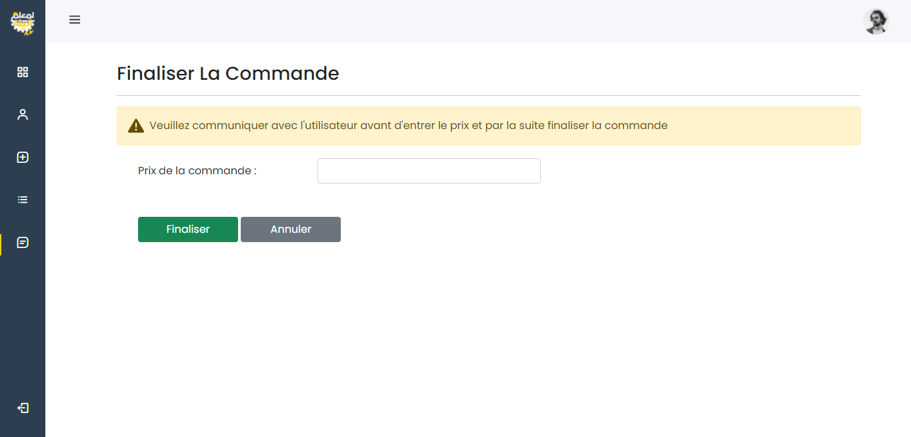

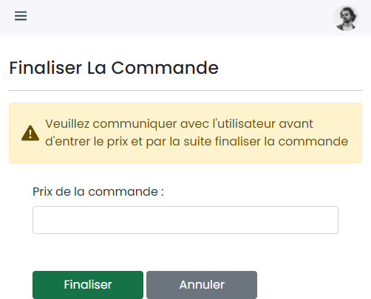

**List of services page mobile & desktop version :**

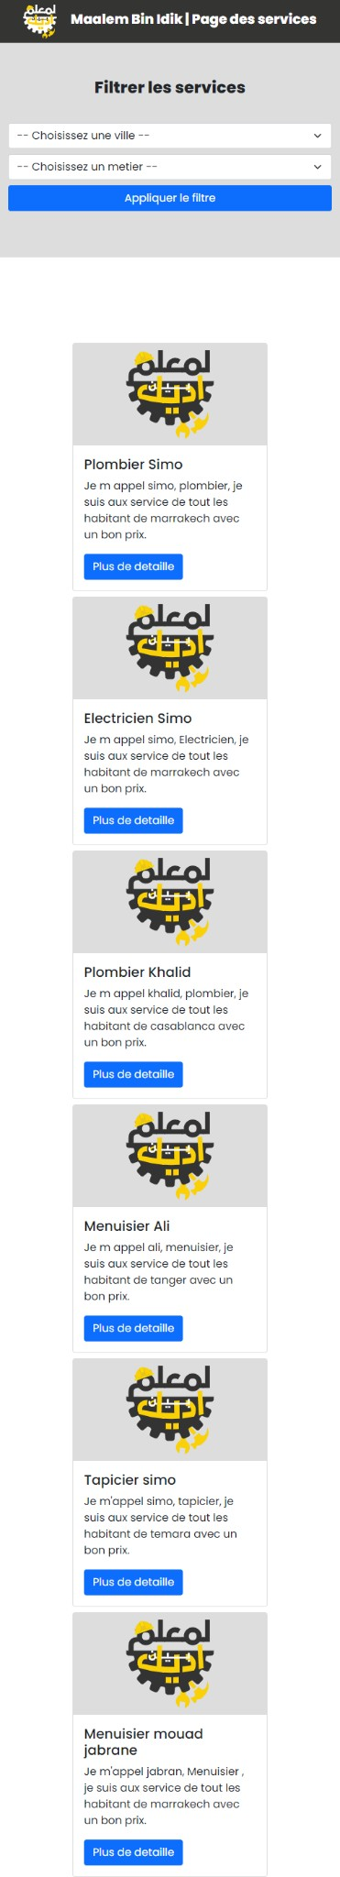

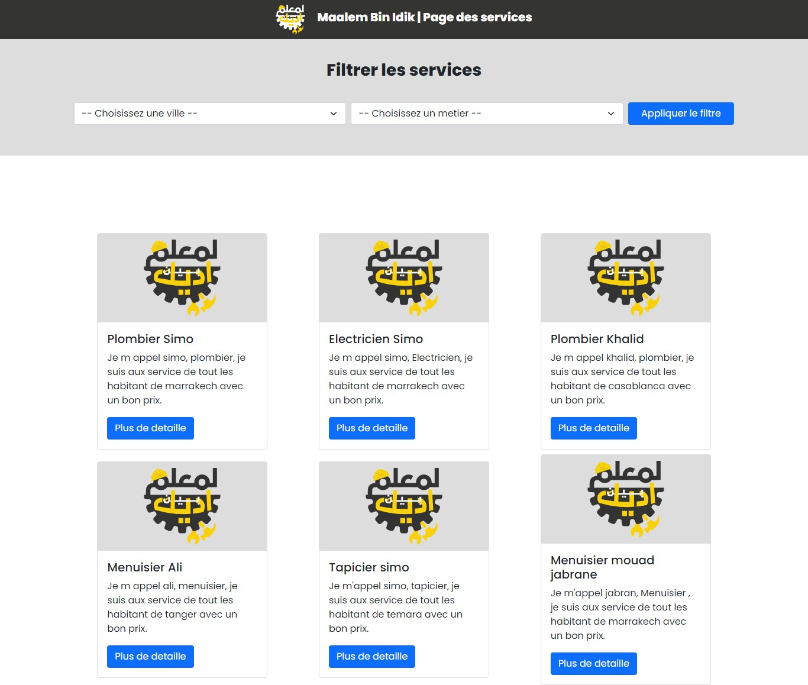

**Service details page mobile & desktop version :**

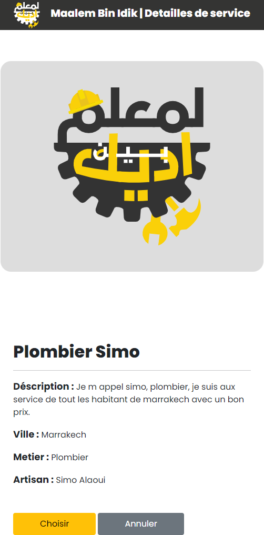

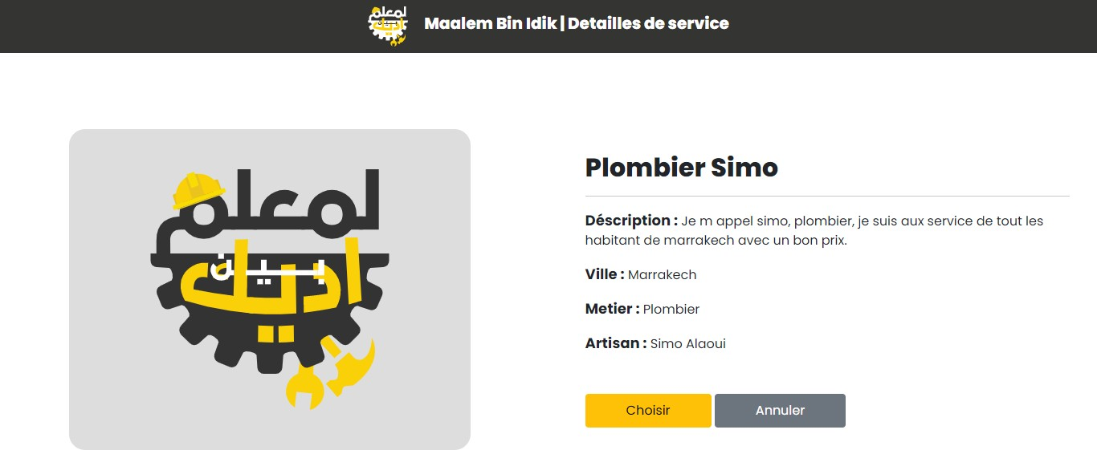

**Order validation page desktop&mobile version :**

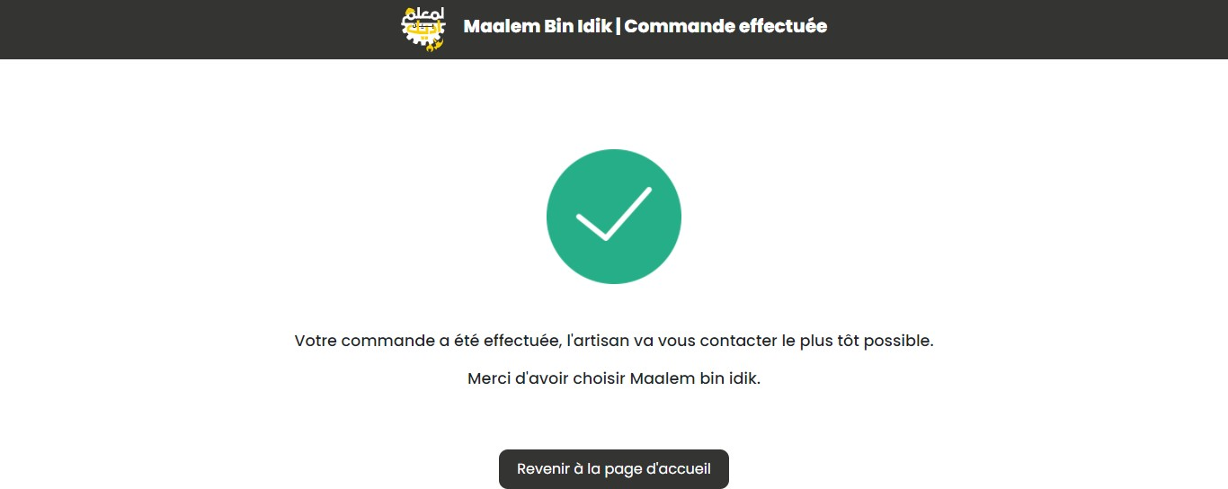

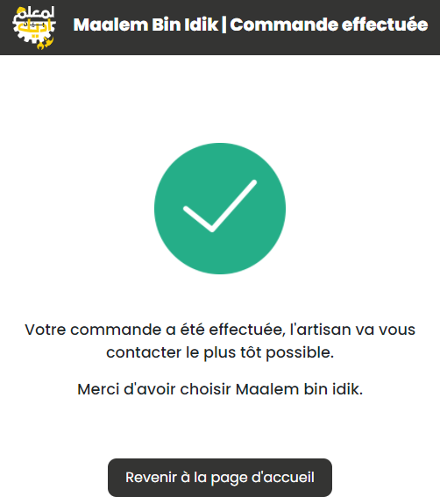

**Security measures taken into consideration**

* 1. Cross-Site Request Forgery (CSRF) - fixed
  2. Version Disclosure (ASP.NET MVC) - fixed
  3. Sensitive Data Exposure - fixed
  4. Full database backup maintenance plan
  5. Schedule for the maintenance plan has been set every week at 12 am